Experiment 4
Aim : To study C++ console I/O operations
THEORY:
What is a stream?
The I/O system in C++ is designed to work with a wide variety of devices including terminals, disks and tape drives. Although each device is very different, the I/O system supplies an interface to the programmer that is independent of the actual device being accessed. This interface is known as stream.

In C++ Programming, the console IO operations are performed using the header file iostream.h. This header file provides two objects cin and cout to perform input and output operations respectively.
There are mainly two types of consol IO operations.
- 1. Unformatted consol IO -
- 2. Formatted consol IO

Unformatted console IO operations

- We use the following built-in functions to perform operations of type unformatted consol IO operations.

⇢ get( ) and put( )
The get( ) is a method of cin object used to input a single character from the standard input device (keyboard). Its main property is that it allows wide spaces and newline character. The get() function does not have any return value (void get( )).
The put() is a method of cout object and it is used to print the specified character on standard output device (monitor).

⇢ getline(char *buffer,int size) and write(char * buffer, int n)
The getline(char *buffer,int size) is a method of cin object and it is used to input a string with multiple spaces.
The write(char * buffer, int n) is a method of cout object and it is used to read n character from buffer variable.

⇢ cin and cout objects
The cin is the object used to take input value of any variable of any type. It must be used with an overloaded operator “>>”.
The cout is an object used to print string and variable values. It must be used with an overloaded operator “<<”.

Formatted console IO operations

The C++ programming language provides the following built-in functions to display the output in formatted form. These built-in functions are available in the header file iomanip.h.

⇢ setw(int) and setfill(char)
The setw( int ) is a method used to set width of the output.
The setfill(char) is a method used to fill specified character at unused space.
precison(n)
This method is used for setting floating point of the output.
setf(arg 1, arg,2)
This function is used for setting format flags for output.
It is used to set specific format flags. The format flags of a stream affect the way data is interpreted in certain input functions and how it is written by certain output functions. See ios_base::fmtflags for the possible values of this function's arguments
We can use the setf() function to configure formatting for the cout object. We pass the setf() function arguments made up of ios_base class constants such as ios_base::boolalpha to display bool values as true or false instead of 1 or 0, and ios_base::showpoint to show a trailing decimal point.
Syntax:
setiosflags(argument 1, argument 2);
resetiosflags(argument 2);
setbase(arg)
This function is used to set basefield of the flag.
Syntax:
setbase(argument);
By default, cout displays char values as one character wide, int values are displayed as base 10 numbers in fields sized to the number of positions in the number, strings are likewise displayed in fields of the same length as the number of characters in the string, and floating point numbers are by default displayed in fields of six digits, with trailing zeros cut off, and the decimal portion truncated as needed.
We can use the cout member function width() to specify how wide we want output fields to be. We can also use the manipulators right and left to make the output right or left justified.

1. Write a C++ program to print the following output using ios class member functions(fig-expt4A)
#include<iostream>
#include<cmath>
using namespace std;
int main()
{
cout.fill('*');
cout.setf(ios::left,ios :: adjustfield);
cout.width(10);
cout<<"VALUE";
cout.setf(ios::right,ios::adjustfield);
cout.width(15);
cout<<"SQRT_OF_VALUE"<<endl;
cout.fill('.');
cout.precision(4);
cout.setf(ios::showpoint);
cout.setf(ios::showpos);
cout.setf(ios::fixed,ios::floatfield);
for(int i=1;i<=10;i++)
{
cout.setf(ios::internal,ios::adjustfield);
cout.width(5);
cout<<i;
cout.setf(ios::right,ios::adjustfield);
cout.width(15);
cout<<sqrt(i)<<endl;
}
}
OUTPUT:

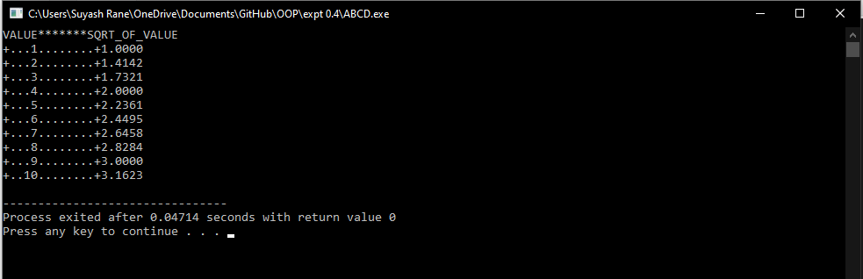

2. Write a C++ program which reads a text from keyboard and display the following information on screen in 3 column format
- Number of lines
- Number of words
- Number of characters
Strings should be left justified and numbers to be right justified. Use suitable field width
#include<iostream>
#include<string.h>
using namespace std;
int main()
{
char c,s[100];
int i,a,d,ch;
i=0;
cin.get(c);

do{
s[i] = c;
cin.get(c);
i++;

}while(c!='^');
int n = strlen(s);
i=a=d=ch=0;
while(i<n)
{

if(s[i]=='\n')
d++;
if(s[i]==' '||s[i]=='\t'||s[i]=='\n')
a++;
if(s[i]>='a'&&s[i]<='z'||(s[i]>='A'&&s[i]<='Z')||s[i]>='0'&&s[i]<='9')
ch++;
i++;
}
cout.setf(ios::left,ios::adjustfield);
cout.width(17);
cout<<"Number of lines";
cout.width(17);
cout<<"Number of words";
cout.width(21);
cout<<"Number of characters"<<endl;
cout.setf(ios::right,ios::adjustfield);
cout.width(13);
cout<<d;
cout.width(17);
cout<<a;
cout.width(22);
cout<<ch;
}
OUTPUT:

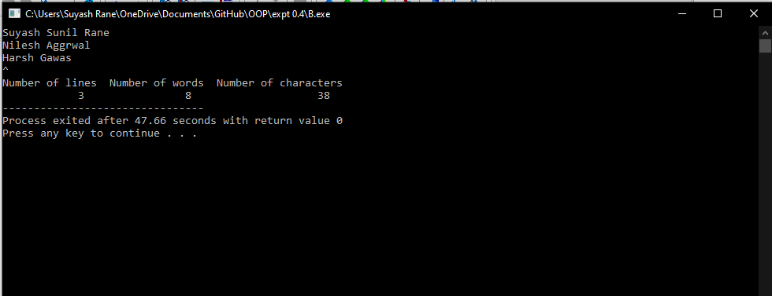

3. Write a C++ program to format the following o/p using manipulators(fig-expt4C)
#include<iostream>
#include<cmath>
using namespace std;
int main()
{
float s=0;
cout.width(5);
cout<<"n";
cout.width(15);
cout<<"Inverse_of_n";
cout.width(15);
cout<<"Sum_of_terms"<<endl;
for(int i=1;i<=10;i++)
{
s=s+1/(float)i;
cout.width(5);
cout<<i;
cout.width(15);
cout.precision(5);
cout.setf(ios::scientific,ios::floatfield);
cout<<(1/(float)i);
cout.precision(4);
cout.setf(ios::fixed,ios::floatfield);
cout.width(15);
cout<<s<<endl;
}

}

OUTPUT:
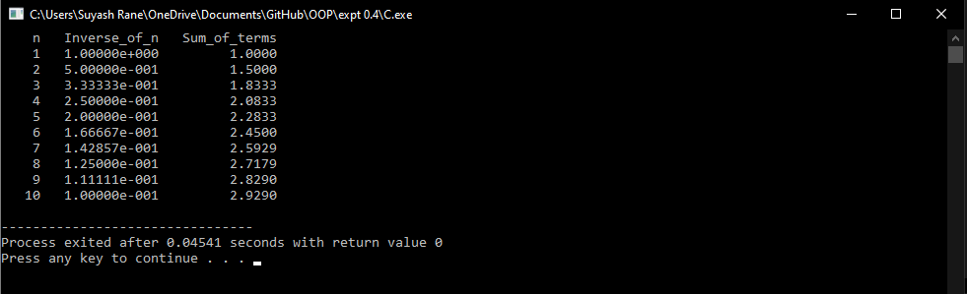

Conclusion:
We can design our own manipulators for certain special purposes in C++ but not in C
We can design our manipulator using manipulator function, which can not be done by ios member functions
A programmer can define a manipulator that could represent a set of format functions.
The flags set by setf() remain effective until they are reset or unset
A format flag can be reset any number of times
We can apply more than one format controls jointly on an output value.
Precision also stays in effect until reset

